SE TERM PROJECT
Software Requirements Specification

AI Dress Code Compliance System



Project Advisor:

Syed Zeeshan Hussain

Presented by:
Group ID: 015

Student Reg#: Student Name:

BSAIM_006 Ayesha Manzoor

Faculty of Computer Science and Information Technology

The Superior University

Software Requirements Specifications

Version # Final
AI Dress Code Compliance System

Advisor: Sir Zeeshan

Member Name | Primary Responsibility | % Contribution | Roll No | Serial # | Sign
Ayesha Manzoor | References, Requirement Analysis, Cost Estimation  Development and testing (implementation , testing, deployment),  System Design (Diagrams), Documentaion |  | 006 | 1

Table of Contents

1. Introduction and Background 8
1.1 Product (Problem Statement) 8
1.2 Background 8
1.3 Scope 9
1.4 Objective(s)/Aim(s)/Target(s) 9
1.5 Challenges 9
1.6 Learning Outcomes 9
1.7 Nature of End Product 10
1.8 Completeness Criteria 10
1.9 Business Goals 10
1.10 Related Work/ Literature Survey/ Literature Review 10
1.11 Document Conventions 11
2. Overall Description 11
2.1 Product Features 11
2.2 User Classes and Characteristics 11
2.3 Operating Environment 12
2.4 Design and Implementation Constraints 12
2.5 Assumptions and Dependencies 12
3. Project Management. 13
3.1 Work Breakdown Structure (WBS). 13
3.2 Create Milestone table 14
3.3 Develop an Activity Graph. 14
3.4 Find the Critical Path. 15
3.5 Create a Gantt chart. 15
~~~~~~~~~~ Phase II ~~~~~~~~~~ 16
4. Functional Requirements 16
4.1 Real Time Dress Code Detection(UC_1) 17
4.2 Violation Logging and Snapshot Capture (UC-2) 18
4.3 Daily Compliance Report Generation (UC-3) ………………………………………………...19
Requirements Analysis and Modeling 20
5. Nonfunctional Requirements* 21
5.1 Performance Requirements 21
5.2 Safety Requirements 21
5.3 Security Requirements 21
5.4 Additional Software Quality Attributes 21
6. Other Requirements 22
7. Designing 23
7.1 Complete class diagram 23
7.2 Complete Data Flow Diagram (DFD) 24
7.3 Complete ER Diagram 25
7.4 Physical design of your database 26
7.5 Information on use of design patterns while designing the modules 27
7.6 Make a Sequence and a Collaboration diagram of following. 28
7.6.1 Scenario 1 28
7.6.2 Scenario 2 29
8. Estimation 30
8.1 Cost Benefit Estimation 30
8.1.1 Return of Investment (ROI) {1st year} 31
8.1.2 %gain on ROI {1st year} 31
8.1.3 Payback Period in years 31
8.2 FP based Estimation 32
8.3 COCOMO Estimation 33
9. References 34
Appendix A: Glossary 34

List of Figures

Figure 1: Use Case Diagram of AI Dress Code Compliance System .......... 16

Figure 2: Activity Graph ...................................................... 14

Figure 3: Gantt Chart ......................................................... 15

Figure 4: Data Flow Diagram (Level 0 – Context Diagram) ........................ 24

Figure 5: Data Flow Diagram (Level 1) .......................................... 24

Figure 6: Entity Relationship Diagram (ERD) .................................... 26

Figure 7: Class Diagram ....................................................... 23

Figure 8: Sequence Diagram – Compliant Employee Scenario....................... 28

Figure 9: Collaboration Diagram - Compliant Employee Scenario ................ 28

Figure 10: Sequence Diagram - Non-Compliant Employee ………………..29

Figure 11: Collaboration Diagram: Compliance Check for Non-Compliant Employee……………..29

List of Tables
Table 1: Use Case UC-1 – Real-Time Dress Code Detection....................... 17
Table 2: Use Case UC-2 – Violation Logging and Snapshot Capture ............... 18
Table 3: Use Case UC-3 – Daily Compliance Report Generation ................... 19
Table 4: Detection Record Table Structure ..................................... 26
Table 5: Daily Reports Table Structure ........................................ 27
Table 6: Users Table Structure ................................................ 27
Table 7: Cameras Table Structure .............................................. 27
Table 8: Cost-Benefit Estimation (Development Costs).......................... 30
Table 9: Annual Operating Costs............................................... 30
Table 10: Annual Benefits..................................................... 30
Table 11: Function Point Components (UFP Calculation) ........................ 32
Table 12: Value Adjustment Factor (VAF) ....................................... 32
Table 13: COCOMO Estimation Summary .......................................... 33

Introduction and Background
In this document, the Software Requirements Specification of an AI-based Dress Code Compliance System is presented. The concept of this project was inspired by the necessity of automating the procedure of monitoring the employees to comply with the dress code policy at their workplace. Dress code is a key aspect of professionalism in most organizations although it is not feasible to check it out on a daily basis. We, therefore, chose to develop a system that employs Artificial Intelligence, and Computer Vision to automatically perform this task using CCTV cameras.
The system records real time video footage of the CCTV camera fitted at the main entrance of the office. It then processes the video frames in real-time to identify the wearable by the individual. When the individual is adhering to the dress code, he will be identified as having been compliant by the system as defined by a green bounding box. When the individual is not adhering to the dress code the system indicates that he is not in compliance through a red bounding box. By so doing, the management is able to easily track compliance without necessarily checking all the employees one by one.

Product (Problem Statement)
At most companies and factories, employees must adhere to a particular dress code. This could be a formal shirt, tie, ID card, safety helmet or other things as per the place of work. At present, the majority of organizations use security guards or HR personnel to verify the dress code at the gate which is tedious, inconsistent and in most cases may result in either arguments or favouritism.
The issue is that manual checking is not credible. During rush hours, guards may overlook violations, or they may just allow some individuals to go without inspection. We also do not have a record of the violator of the dress code and the time. This complicates the management to take any action or monitor trends overtime.
In the case of our solution, we have suggested an AI Dress Code Compliance System which involves a CCTV camera and computer vision algorithm to detect dress code violations in real time. The system will determine whether the employee is wearing the necessary items or not and produce alerts and reports to the management.

Background
Incorporation of dress code has always been a problem in corporate and industrial settings. Businesses waste time and resources on the manual monitoring, and the outcomes are not always satisfactory. As AI and deep learning technologies have developed, now visual inspection work that was once performed by humans can be automated.
Computer Vision is a branch of Artificial Intelligence that deals with how computers can understand and interpret visual information from the real world, such as images and videos. In the recent years, models such as YOLO (You Only Look Once) have allowed the high-speed and accuracy of detecting objects in pictures. These models can be trained using custom datasets to identify particular objects, such as shirts, ties, helmets, and ID cards.
These technologies are the basis of our project. Our model is based on a pre-trained deep learning model that we fine-tune with a custom dataset of dress code items. The system then operates on a local computer networked to the CCTV camera and feeds on the video in real time.

Scope
The areas that this project will address are:
• Single CCTV camera that captures video in real-time at the entrance of the office.
• Identification of dress code e.g. formal shirt, tie, ID card and other mandatory clothing.
• Graphical representation of complying employees by using green bounding boxes and non- conforming employees by using red bounding boxes.
• Producing reports on compliance to management daily.
• The version that is available is oriented to a single camera. Future versions will be supported by multi-cameras.

Objective(s)/Aim(s)/Target(s)
• To establish an AI model to trace the adherence of the dress code based on the footage provided by CCTV cameras in real time.
• To minimize the reliance of security guards on manual monitoring.
Purpose: To give visual cues (green/red bounding boxes) to rapidly detect violations.
• To develop an automated report generating feature, which will aid management to track compliance data.
- To apply concepts of deep learning and computer vision in a practical, real-world scenario.

Challenges
In this project, we are likely to encounter some challenges:
• Good quality data set of dress code items is not easy to collect since there are limited publicly available datasets of dress code items in this particular application. We were required to take and tag our own pictures.
• The lighting at the entrance may change during the day and this can influence the precision of the detection.
• There is a possibility of several individuals going through the entrance during peak hours and it would be difficult to trace every person.
• Video processing in real time involves a good GPU; hence, it costs more hardware.
• One of the issues is to ensure privacy of the employees when they are captured and analyzed in the images.

Learning Outcomes
Through the accomplishment of this project, we will be able to acquire the following skills and knowledge:
- Experience with a deep learning system such as TensorFlow or PyTorch.
• Knowledge about the principles of object detection models such as YOLO and how to train them to use custom data.
• Familiarity with processing real-time video feeds with OpenCV library in Python.
• Knowing how to gather, label, and make image datasets to be trained.
• Knowledge of complete software development cycle of requirements collection to deployment.

Nature of End Product
The final product would be a desktop AI application executed on a local computer, which connects to a CCTV camera. It is neither a web-based application nor a mobile application. The system receives a live video stream as an input and runs each frame through a trained deep learning model and displays the results onscreen with visual cues indicating whether the individual each person is adhering to the dress code or not.
Snapshots of violations are also saved in the application and summarize report is drawn at the end of every day. The HR or management team can be presented with this report to take action on the same.

Completeness Criteria
The project will be considered to be complete once the following conditions are fulfilled:
• The system is able to record a video of a CCTV camera and handle it in real time without much delays.
- The object detection model is able to identify at least three pieces of dress code (could be formal shirt, tie, and ID card) with an accuracy of at least 80 percent.
• The system will appropriately label conforming individuals with green boxes and those who are violators with red boxes.
- A summary report is created and stored in readable format on a daily basis.

Business Goals
Although this is a scholarly project, the system is to be created with the real business requirements in mind. The following are the business objectives that this system is targeting:
• Lessening the effort and expense of manual surveillance of dress codes.
• Enhancing uniformity and equity in enforcement as the AI does not differentiate among people.
• Supplying the management with information about trends in employee compliance over time.
• Developing a solution that can be scaled so to speak to additional cameras and locations in the future.

Related Work/ Literature Survey/ Literature Review
We analyzed some of the available research papers and projects on our topic. The following is a short overview of the work which made us get to know the field better:
A similar idea was produced by Khan et al. (2021) who trained a convolutional neural network to recognize PPE (Personal Protective Equipment) usage on construction sites. They were able to recognize helmets, safety vests and gloves with an accuracy of approximately 85 percent. Nevertheless, they concentrated on industrial safety equipment and not on office wear, as is the case with our project.
Redmon et al. (2016) introduced the YOLO (You Only Look Once) object detection framework, which changed the way real-time object detection works. YOLO works on the entire image once, which is significantly faster than older algorithms, such as R-CNN. The reason why we selected YOLO as our base model in the project is due to its speed and ability to perform well in real time applications.
Similar approach was applied by Singh and Kumar (2020) who developed a face mask detection system during the COVID-19 pandemic. They trained a YOLO model on a constructed dataset of masked and unmasked faces and achieved real-time detection. Their work provided us with a good reference point to train our model on custom data.
Ahmed et al. (2022) suggested a smart attendance system that employs face recognition along with a dress code check. Their system had a separate classification model which checked whether the person was in a uniform or not. Though their technique was successful, it demanded a database of faces of the employees, which complicates it. In the simplest variant of our system, we are doing dress code detection without face recognition.

According to this literature review, we discovered that although there are numerous object detection systems that detect safety gears and face masks, few of them are specifically dedicated to detect compliance with office dress code. This lack in the current literature inspired us to develop our own system to this end.

Document Conventions
The following conventions have been used throughout this document:
Headings, subheadings and significant terms are typed in bold.
• Such technical terms as YOLO, OpenCV, and CCTV are spelt out in their usual shortened version.
• All the requirements are numbered in the section-based numbering system (e.g., 1.1, 1.2, and so on).

Overall Description

Product Features
The AI Dress Code Compliance System has following features:

- Live Monitoring: It uses a live CCTV monitoring and it automatically checks dress code compliance without human effort.

- Multiple Item Detection: It can detect multiple dress code items simultaneously such as formal shirt, tie, ID card and more.

- Visual Indicators: It uses a green bounding box for the compliant ones and a red bounding box for the non-compliant.

- Snapshot Logging: It logs a snapshot with the date and time when a violation occurs.

- Daily Reports: It generates a simple report every day for the HR or manager to review.

- Local Processing: All the processing is done locally not on a server ensuring privacy.

User Classes and Characteristics
User Class | Description | Technical Level
HR Manager | Reviews daily reports and follows up on violations. | Non-technical
Security Staff | Watches the live detection screen at entrance. | Non-technical
System Administration | Sets up and maintains the system. | Technical
Developer | Updates or retrains the Ai model when needed. | Highly Technical

Operating Environment
- Hardware: PC with an NVIDIA GPU (4GB VRAM) and CCTV camera.

- Operating System: Windows 10/11 or Ubuntu 20.04 or above.

- Programming Language: Python 3.8 or above.

- Libraries Used: YOLOv8, OpenCV, PyTorch, Pandas.

- Camera: Any normal CCTV camera (720p or better) at the office entrance.

- Internet: Not needed during operation. Only required for model training or update.

Design and Implementation Constraints
The system’s performence depends on the GPU of the computer. The detection may slow down with low hardware.The data set is collected from many sites like for tie detection from kaggle, for shirt, t-shirt, sweatshirt, vest and stuff like this from Fashionpedia (huggingface) but for office specific dress code some pictures were taken manually also some dataset was labelled and collected manually. Also the detection may fail if the light is not good. It can fail in dark and also in very bright lighting.
If the dress code changes the model can be retrained.Captured pictures can only be stored and accessed securely by authorized staff only.

Assumptions and Dependencies
Assumptions:

- The CCTV camera is already in place before the system is put into use.
- Staff go in one or two at a time so that the system recognizes them.
- The office dress code items do not change frequently. The system's computer is left on during working hours.

Dependencies:

- Object detection is performed with Ultralytics' YOLOv8 model.
- OpenCV is used for the video feed.
- PyTorch is required to run the model.
- A custom dataset is used to train the system.

Project Management.

Work Breakdown Structure (WBS).
Level 0: AI Dress Code Compliance System
Level 1:
- Planning
- Data Collection
- Model Development
- System Development
- Testing
- Deployment
Level 2 (breakdown):
- Planning
  - 1.1 Understand project requirements
  - 1.2 Study existing systems and research papers
  - 1.3 Define dress code items to detect
- Data Collection
  - 2.1 Collect images from online datasets (COCO, Kaggle)
  - 2.2 Capture additional images manually
  - 2.3 Label and annotate images using Roboflow
- Model Development
  - 3.1 Set up Python environment and install libraries
  - 3.2 Train YOLOv8 model on the dataset
  - 3.3 Test and evaluate model accuracy
  - 3.4 Fine-tune the model to improve results
- System Development
  - 4.1 Connect CCTV camera feed using OpenCV
  - 4.2 Integrate trained model with live video
  - 4.3 Add green/red bounding box display
  - 4.4 Build snapshot logging feature
  - 4.5 Create daily report generation
- Testing
  - 5.1 Test with different lighting conditions
  - 5.2 Test with multiple people entering
  - 5.3 Fix bugs and improve detection
- Deployment
  - 6.1 Install system on office computer
  - 6.2 Connect to CCTV camera
  - 6.3 Train office staff to use the system

Create Milestone table
Milestone | Description | Expected Completion
M1 | Requirements gathering and research completed | Week 2
M2 | Dataset collection and labeling completed | Week 4
M3 | First version of trained model ready | Week 6
M4 | Live camera feed integration done | Week 8
M5 | Bounding box display and logging working | Week 10
M6 | Daily report feature completed | Week 11
M7 | Testing and bug fixing completed | Week 13
M8 | Final deployment and handover | Week 14

Develop an Activity Graph.

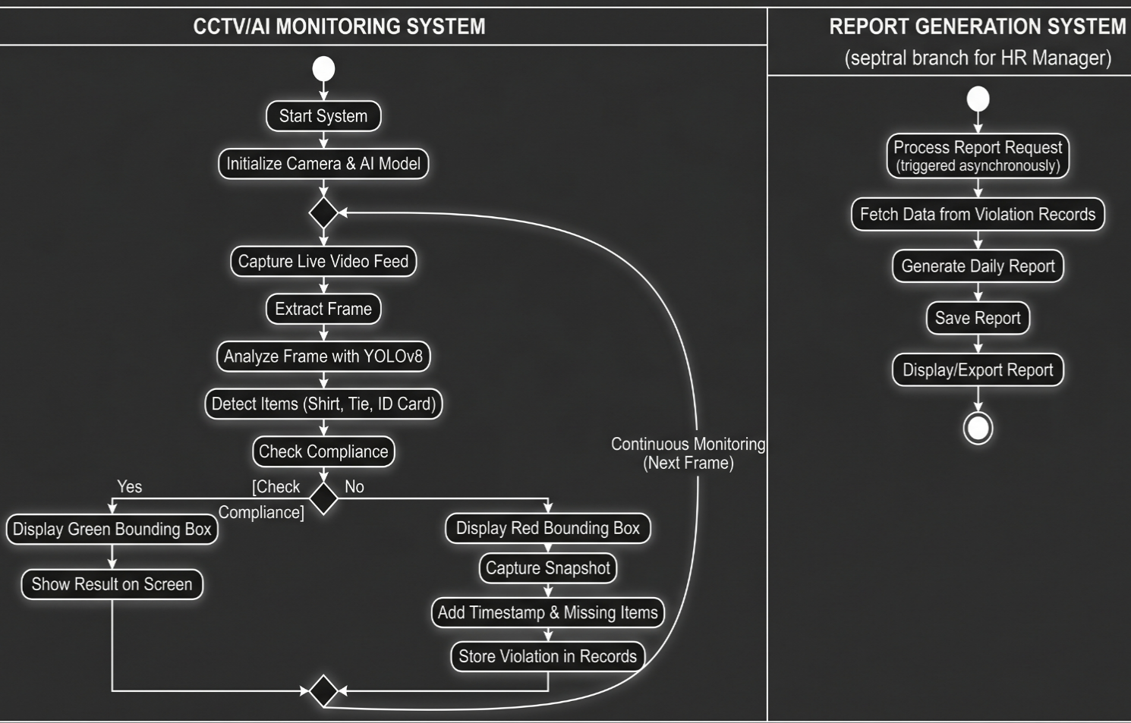

Find the Critical Path.
Critical path:
A → B → C → D → E → F → G → H → I → J

Time Duration:
16 weeks

Analysis:
Due to the linear nature of the project (all activities are in sequence), there is only one path, and all activities are on the critical path with zero float. This is confirmed by the Forward-Backward Pass method shown in the provided CPM diagram.

Create a Gantt chart.

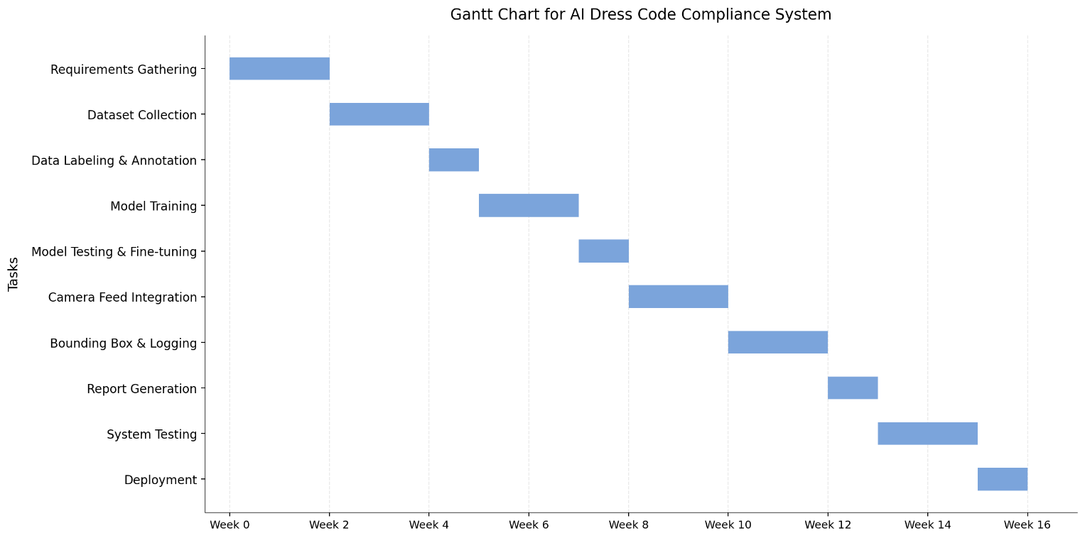

~~~~~~~~~~ Phase II ~~~~~~~~~~

Functional Requirements
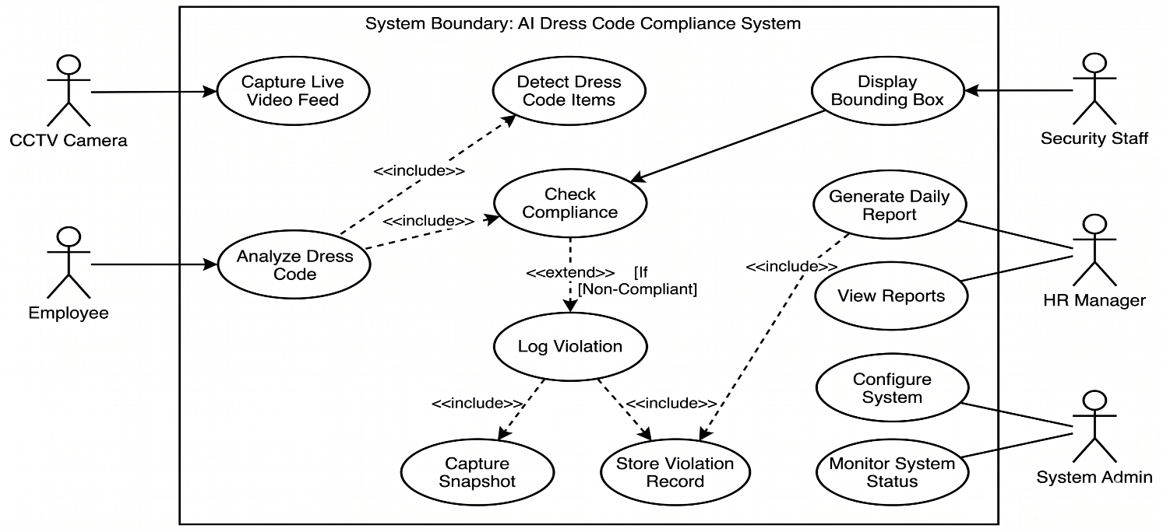

Use Case Diagram Description:
The Use Case Diagram above shows the scope and scope boundaries of the AI Dress Code Compliance System in a local PC environment. The CCTV Camera is a key actor that kicks off the automatic process by feeding a live video feed of the office doorway. The system uses the YOLOv8 deep learning model to process each frame in real-time to identify the required dress code items such as shirts, ties and ID cards.

Key interactions include:
- Visual Feedback: The system automatically incorporates visual feedback (green or red boxes) to the Security Staff.
- Automated Logging: In case of a violation, the system further enhances its operations to capture a screenshot and a timestamp for management review.
- Data Reporting: The HR Manager engages with the system to produce and export daily reports to support data-driven monitoring of workplace professionalism.
- Privacy & Efficiency: All of the key use cases are run on a local computer, which ensures employee data security and does not require cloud computing.

Real-Time Dress Code Detection:
Identifier |  | UC-1
Purpose |  | To automatically detect and analyze the dress code (shirt, tie, ID card) of individuals entering the office via live CCTV feed.
Priority |  | High
Pre-conditions |  | The CCTV camera must be active, and the YOLOv8 model must be loaded on the local system.
Post-conditions |  | Real-time visual feedback (bounding boxes) is displayed on the security monitor.
Typical Course of Action
S# | Actor Action |  | System Response
1 | Employee walks within the range of the CCTV camera at the entrance. |  | System captures the live video frame from the feed.
2 |  |  | System processes the frame using the YOLOv8 model to detect clothing items.
3 |  |  | System checks detected items against the defined dress code policy.
4 |  |  | System draws a Green Bounding Box around the person if all items are present.
Alternate Course of Action
S# | Actor Action |  | System Response
1 | Employee is missing a mandatory item (e.g., no tie or ID card). |  | System identifies the missing requirement.
2 |  |  | System draws a Red Bounding Box around the individual.
3 |  |  | System triggers UC-2 to log a violation snapshot.
Table 1: UC-1

Violation Logging and Snapshot Capture:
Identifier |  | UC-2
Purpose |  | To capture and save visual evidence (snapshots) of individuals who are not complying with the dress code policy.
Priority |  | High
Pre-conditions |  | A dress code violation must be identified by the AI model in UC-1.
Post-conditions |  | A snapshot of the violation is stored in the local database with a valid timestamp.
Typical Course of Action
S# | Actor Action |  | System Response
1 |  |  | System receives a trigger from UC-1 indicating a violation.
2 |  |  | System captures the specific frame where the violation was detected.
3 |  |  | System adds a metadata overlay including the date, time, and specific missing items.
4 |  |  | System saves the image file to the local storage directory.
Alternate Course of Action
S# | Actor Action |  | System Response
1 |  |  | System attempts to save the snapshot but detects insufficient local storage.
2 |  |  | System generates an alert on the UI for the System Admin to clear space.
3 |  |  | System continues live monitoring but pauses logging until space is available.
Table 2: UC-2

Daily Compliance Report Generation:

Identifier |  | UC-3
Purpose |  | To generate a daily summary of dress code compliance for management review.
Priority |  | Medium
Pre-conditions |  | System must have logged data/snapshots in the local database for the day.
Post-conditions |  | A PDF/CSV report is generated and saved locally.
Typical Course of Action
S# | Actor Action |  | System Response
1 | HR Manager selects the "Generate Daily Report" option. |  | System queries the local database for all logs of the current date.
2 |  |  | System compiles total count of employes detected and total violations.
3 |  |  | System formats the data into a structured report with timestamps.
4 |  |  | System exports the report as a file.

Alternate Course of Action
S# | Actor Action | System Response
1 |  | System searches the database but finds zero logs for the selected date.
2 |  | System displays a notification: "No compliance data available for this date."
3 |  | System cancels the report generation process to avoid creating an empty file.

Table 3: UC-3

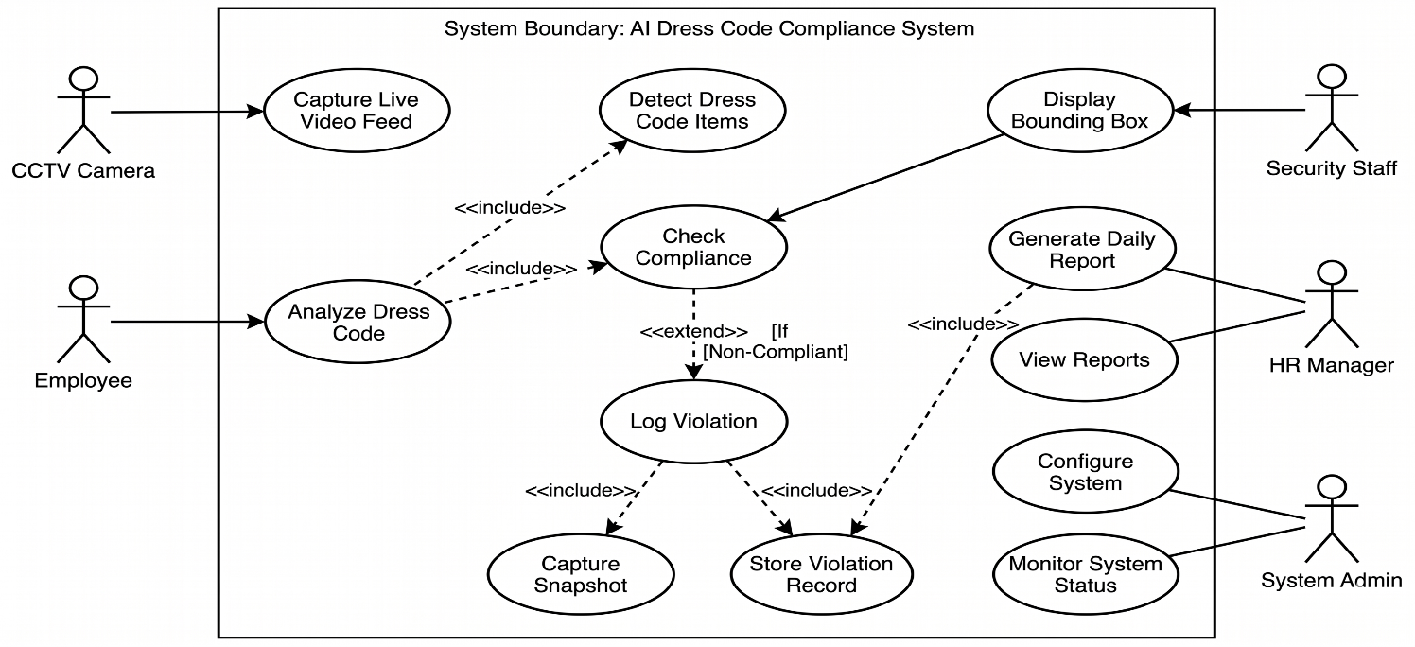
Requirements Analysis and Modeling:

Use Case Diagram Description:

The Use Case Diagram illustrates the functional requirements of the AI Dress Code Compliance System. It identifies the interaction between external actors and the system's core functionalities:

Actors:

- CCTV Camera: Acts as the primary input source by capturing the live video feed.
- Employee: The subject of analysis whose attire is checked against the policy.
- Security Staff: Receives real-time visual feedback via bounding boxes.
- HR Manager: Responsible for generating and reviewing daily compliance reports.

Key Relationships:

The Analyze Dress Code use case is central to the system, utilizing the YOLOv8 model.
It includes the display of bounding boxes and extends to logging a violation snapshot if an employee is non-compliant. The Generate Daily Compliance Report use case depends on the logged violation data, and is primarily accessed by the HR Manager.

Nonfunctional Requirements*

Performance Requirements
The system shall be able to process the live stream at a minimum of 15 frames per second with a computer with a minimum of 4GB NVIDIA GPU. It shall process each frame and display the detection result within 2 seconds of their entry into the frame. The system shall be capable to detect and identify up to 3 dress code items (formal shirt, tie, ID card) simultaneously on a person. The real-time box overlay shall not have any noticeable lag on the monitor. The compliance report shall take no longer than 30 seconds to produce, no matter how many logs are recorded.

Safety Requirements
The system shall not retain any biometric information like fingerprints or facial templates. It shall only store images of dress code breaches and these images shall be removed after 90 days to prevent an over-accumulation of data. The system shall not be physically harmful as it only uses the camera to monitor and not physically come in contact with workers. In case of system failure or shutdown, the system shall not damage the violation data stored. If the camera signal is lost, the system shall notify the administrator of the system.

Security Requirements
Violation records and daily reports shall only be accessible by administrators. The report section shall be protected by a password for the HR Manager. Snapshots of violations shall be saved in a secured directory on the local computer that is not accessible to normal users. The system shall not share any data via the internet, and all employee data shall remain local. If the system is networked for updates it shall only use HTTPS.

Additional Software Quality Attributes
- Reliability: The system shall achieve a detection accuracy of at least 85% in typical office lighting conditions (300-500 lux). This is the average performance of a standard YOLOv8 model on a custom trained data set as outlined in the Ultralytics YOLOv8 documentation.

- Usability: Security personnel monitoring the real-time screen shall be able to understand the green and red bounding box system after only 15 minutes of training. The system shall have an intuitive interface that can be used by a non-technical user.

- Maintainability: The code shall be written in separate Python files, so individual parts of the system, such as the detection module, logging module and report module can be updated easily without needing to restart the whole system.

- Availability: The system shall run for at least 8 hours continuously during the working hours without restarting. In the case of a minor error, the system shall restart automatically and continue to monitor.

- Portability: The system shall work on both Windows 10/11 and Ubuntu 20.04 or higher with no modifications to the main code. The differences could be the setup of the camera driver.

- Scalability: The system shall support only one camera. But the system shall support multiple cameras with minimal changes to the current system.

Other Requirements
Hardware Requirements:
A personal computer with an NVIDIA GPU with at least 4GB of VRAM is needed to run the YOLOv8 detection model. A typical HD CCTV camera (minimum 720p) should be connected to the computer via USB or IP. The machine should be able to accommodate 8GB of memory and 50GB of storage space to accommodate daily and monthly reports and violation snapshots (images).

Software Requirements:
The program is developed in Python 3.8 or later. The key libraries include YOLOv8 from Ultralytics for detection, OpenCV for video stream processing, PyTorch for deep learning and Pandas for report generation. The system can run on either Windows 10/11 or Ubuntu 20.04 and above.

Database Requirements:
In the current version, the system does not employ a database management system. Violation logs and snapshots will be saved locally in folders and giving the file a date and time stamp. Reports are exported to CSV or PDF. In future, if the system is expanded, a MySQL or SQLite database can be used to store a large volume of data.

Communication Interface Requirements:
The system does not need to be connected to a network or the internet. All detection and logging occurs on the local computer. The internet is only required for updating models and new libraries. The system does not communicate with any server, thus ensuring privacy of employee data.

Legal Requirements:
Images of the employees are taken at the entry, so the company should notify employees that CCTV surveillance with AI detection is implemented. The camera should have a sign indicating that people are being monitored. The company needs to adhere to its own data privacy policies for saving and viewing violation images.

Reuse Objectives: The model and code for detection are modular and can be used for other similar purposes. For instance, the system can be used to check for PPE (Personal Protective Equipment) compliance in factories or to detect safety equipment in a construction site by training the model with a new dataset.

Designing

Complete class diagram
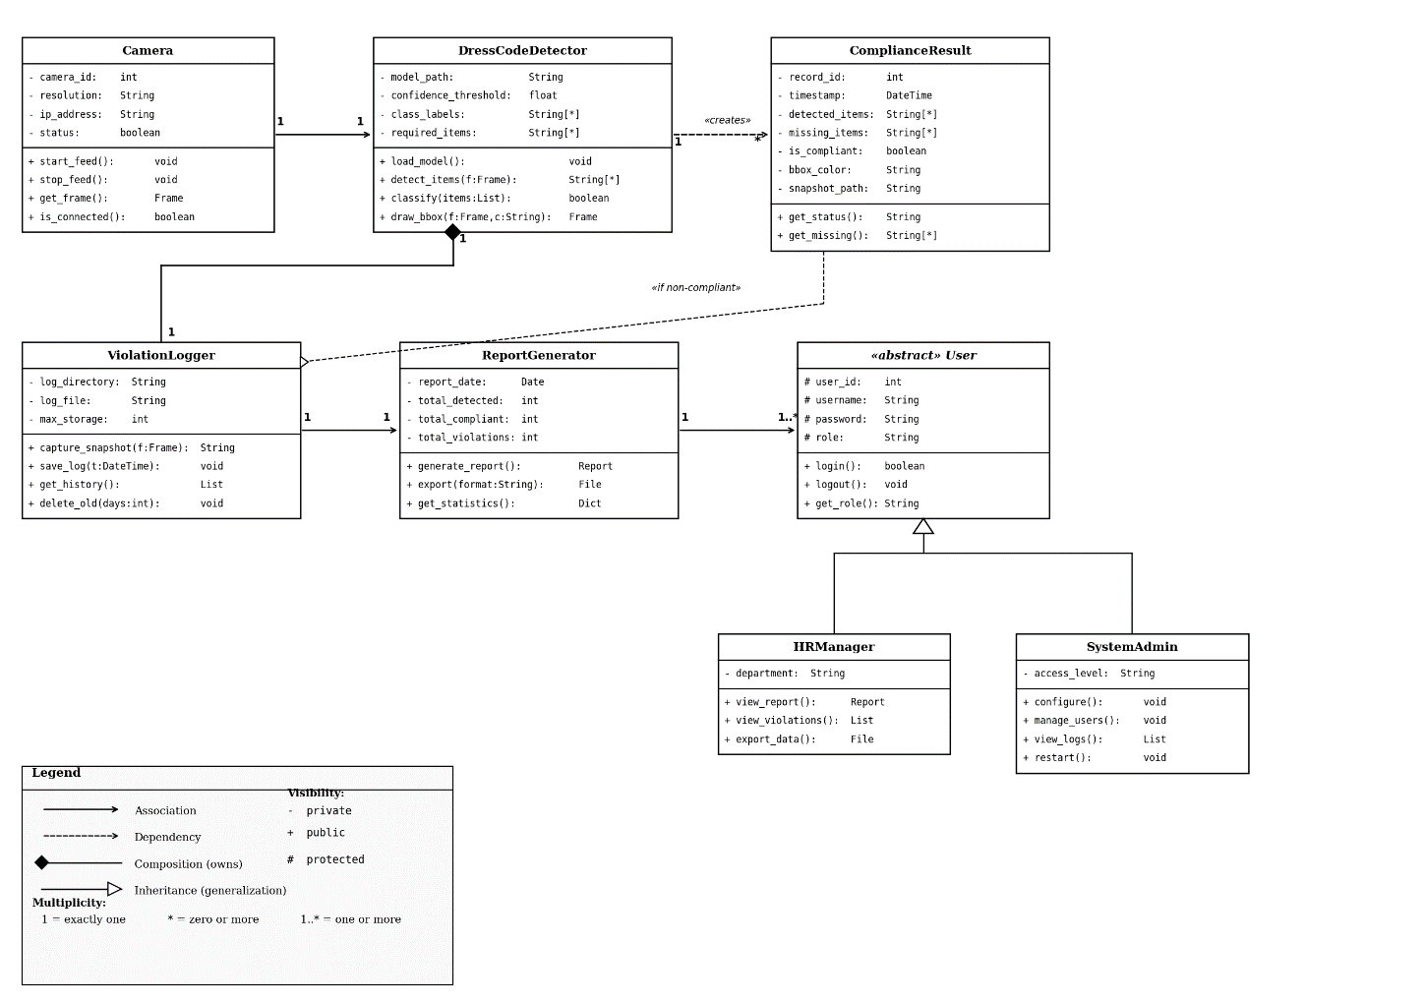

Complete Data Flow Diagram (DFD)
Level 0(Context level):

- The system is depicted in the context diagram as a single process that communicates with five other entities.
- The system receives a video stream from the CCTV Camera.
- The system receives the physical appearance of the Employee from the camera.
- The Security Staff is provided with visual feedback on the screen in real-time (green or red boxes).
- The HR Manager receives compliance reports daily and can review historical compliance violation details.
- The System Admin sets up configurations and gets system status reports.

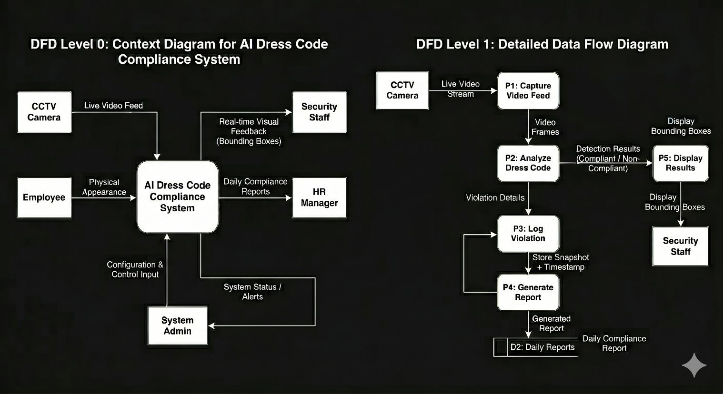

Level 1:

- The Level 1 diagram illustrates the system in five internal processes and two data stores.
- P1 (Capture Video Feed) takes the raw video stream from the CCTV Camera and feeds this to P2.
- P2 (Analyze Dress Code) uses the YOLOv8 model to detect clothing items in the frame and check for dress code violations.
- In case of a violation, P2 passes the violation details to P3 (Log Violation) which takes a photo of the person and stores it with a time stamp in D1 (Violation Records).
- P4 (Generate Report) reads data from D1 and generates a daily report summarizing the compliance which is stored in D2 (Daily Reports) and delivered to the HR Manager.
- P5 (Display Results) takes the results from P2 and shows the Security Staff the bounding box feedback.

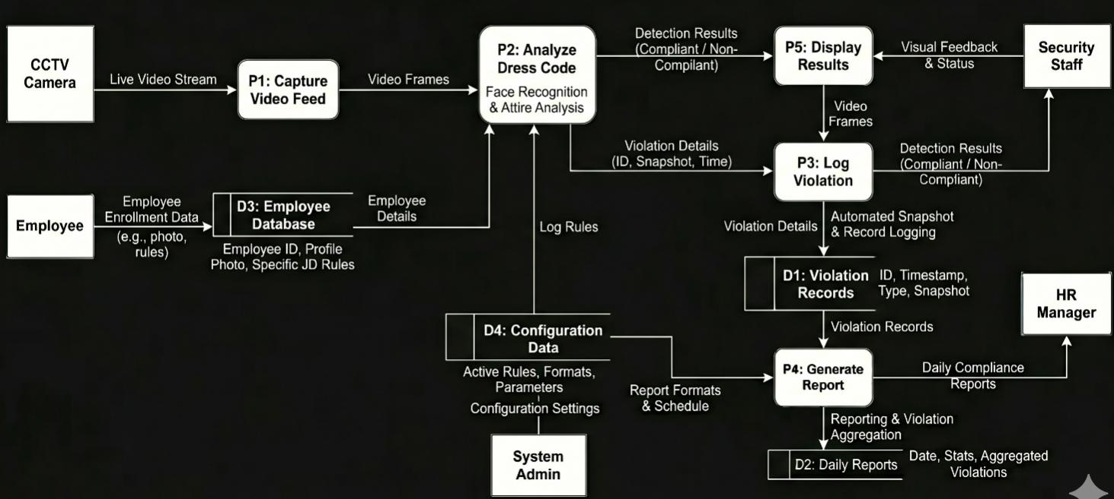

Complete ER Diagram
The following Entity Relationship Diagram shows the data model of the AI Dress Code Compliance System. This diagram shows four key entities and their relationships.

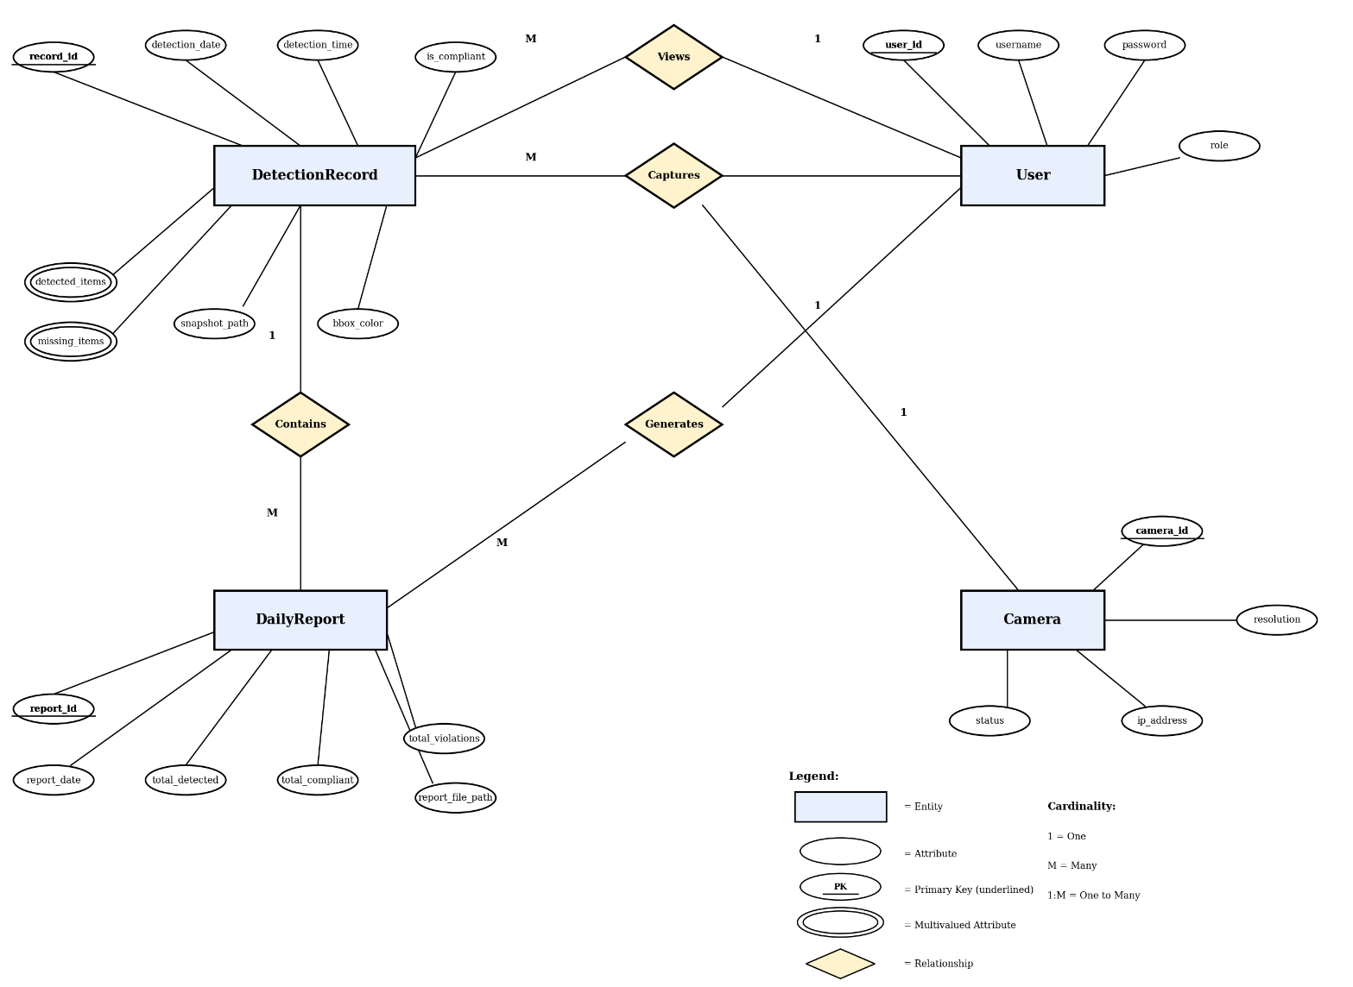

Entities:

- DetectionRecord holds each detection record with the date and time, compliance result (whether the person is in dress code or not), detected items and missed items, snapshots path and the color of the bounding box. The record_id is the key attribute. The detected_items and missing_items attributes are multivalued as individuals can wear or miss multiple dress code items.
- DailyReport contains the summary of the compliance per day such as the number of people detected, compliant and violation and the location of the report file. The report_id is the primary key.
- User stores the details of the users of the system such as the HR Manager and System Admin. It Stores user_id, username, password and role.
- Camera stores the information of the CCTV camera such as camera_id, resolution, IP address and status.

Relationships:

- A DailyReport has many DetectionRecords (1:M). The report is a summary of the detections for the day.
- A User creates many DailyReports (1:M). The HR Manager or Admin can generate a report for any date.
- A Camera has many DetectionRecords (1:M). A camera generates many DetectionEvents (1:M).
- A User can view many DetectionRecords (1:M). Users can view past violations.

Physical design of your database
The system uses a local storage approach with structured tables.Below is the physical design showing tables names, column names, data types and constraints.

Table 1: Detection Record

Column Name | Data Type | Constraint | Description
record_id | Int | Primary key, auto increment | Unique ID for each detection
detection_date | Date | Not null | Date when the detection occurred
detection_time | Time | Not null | Time when the detection occurred
is_compliant | Boolean | Not null | True if compliant, False if not
detected_items | Varchar(225) | Null | Comma separated list of items found
missing_items | Varchar(225) | Null | Comma separated list of missing items
Snapshot_path | Varchar(500) | Null | File path to the saved snapshot
Bbox_bar | Varchar(10) | Not null | Green for compliant, Red for violation
Camera_id | int | Foreign key | References camera table

Table 2: Daily Reports

Column Name | Data Type | Constraint | Description
report_id | INT | Primary key, auto increment | Unique ID for each report
report_date | DATE | Not null, unique | Date of the report
total_detected | INT | Not null | Total people detected that day
total_compliant | INT | Not null | Number of compliant individuals
total_violations | INT | Not null | Number of violations recorded
report_file_path | VARCHAR(500) | Not null | Path to the generated report file
generated_by | INT | Foreign key | References user table

Table 3: Users

Column Name | Data Type | Constraint | Description
user_id | INT | Primary key, auto increment | Unique user ID
username | VARCHAR(50) | Not null, unique | Login username
password | VARCHAR(255) | Not nul | Hashed password
role | VARCHAR(20) | Not null | Either "admin" or "hr_manager"

Table 4: Cameras

Column Name | Data Type | Constraint | Description
camera_id | INT | Primary key, auto increment | Unique camera ID
resolution | VARCHAR(20) | Not null | Camera resolution (e.g., 720p)
ip_address | VARCHAR(50) | Null | IP address or USB connection
status | VARCHAR(10) | Not null | Active or Inactive

Information on use of design patterns while designing the modules
The following design patterns were used while desihning the modules of the AI Dress Code Compliance System. Such patterns help to keep the code organized, reusable and maintainable.

- Singleton Pattern - Camera Class:
Camera class is a Singleton pattern. There is only one instance of the camera connection made in the app. This ensures that different parts of the code do not access the camera and cause any issues like conflicts and errors. With Singleton, we ensure that the camera is opened only once and we use the same connection everywhere.

- Observer Pattern - DressCodeDetector and ViolationLogger:

The Observer pattern is used between the DressCodeDetector and ViolationLogger class. The DressCodeDetector is the subject that is scanning the frames. It informs the ViolationLogger (the observer) whenever a violation is detected and to take a photo and log the incident. So the detection code and logging codestay seperated. If in the future we want to add another observer, such as sending an email, we can do so without changing the detection code.

- Strategy Pattern - Dress Code Rules:

The Strategy pattern is used in the compliance checking code in DressCodeDetector class. The required items to meet the dress code (formal shirt, tie, ID card) are stored as a configuration. If the company changes the dress code policy, for example to include helmet or exclude tie, we simply update the list of required items but keep the detection code intact. The algorithm for detection doesn't change, only the strategy (dress code items to report).

- Factory Pattern - ReportGenerator Class:

The ReportGenerator class uses a simple Factory pattern to generate reports in various formats. The generate method can create either a PDF or a CSV report based on the format specified. This eliminates the need for special code for each type of report and can easily support new types of reports in the future.

Relevant Classes in Class Diagram:

- Singleton: Camera (only one instance and connection)

- Observer: DressCodeDetector (subject) → ViolationLogger (observer)

- Strategy: DressCodeDetector (list of required items is the strategy)

- Factory: ReportGenerator (export method -> different report types

Make a Sequence and a Collaboration diagram of following.

Scenario 1: Compliant Employee Detection
Description:
An employee walks into the office and passes through the field of view of the CCTV. It identifies the individual, scans the dress code items using the YOLOv8 model, matches all necessary items and displays a green box on the security screen.

Sequence Diagram:

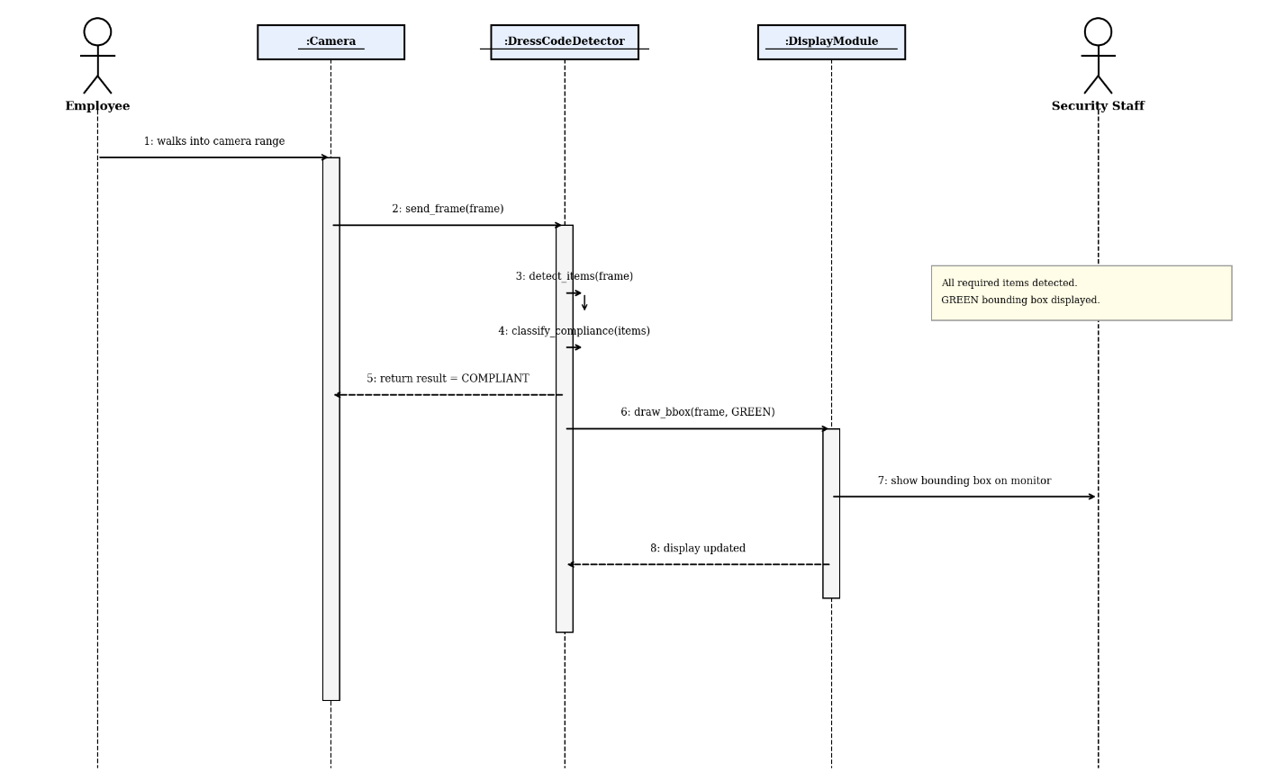

Collaboration Diagram:

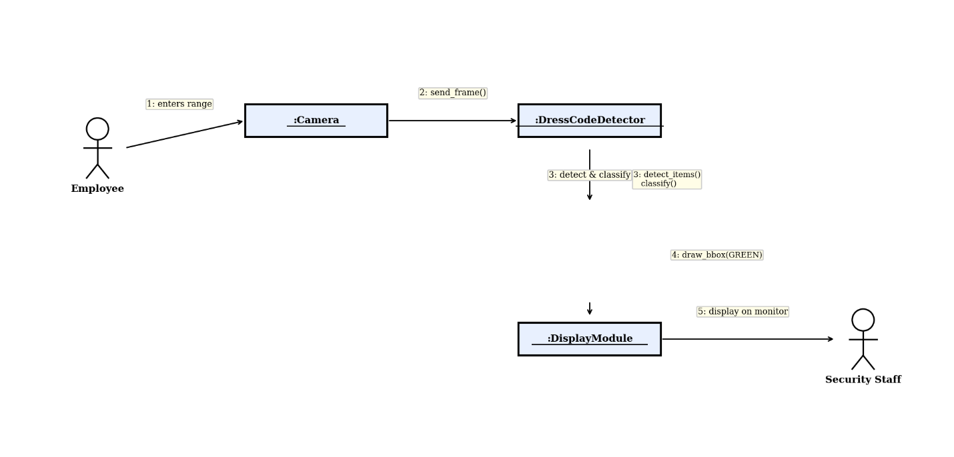

Scenario 2: Miscompliant Employee and Fine Logging
Description:
An employee enters the office, but is not carrying one or more of the dress code items. The system identifies the violation, renders a red bounding box, takes a screenshot and logs the violation with date and time of entry and missing items for review by the HR Manager.

Sequence Diagram:

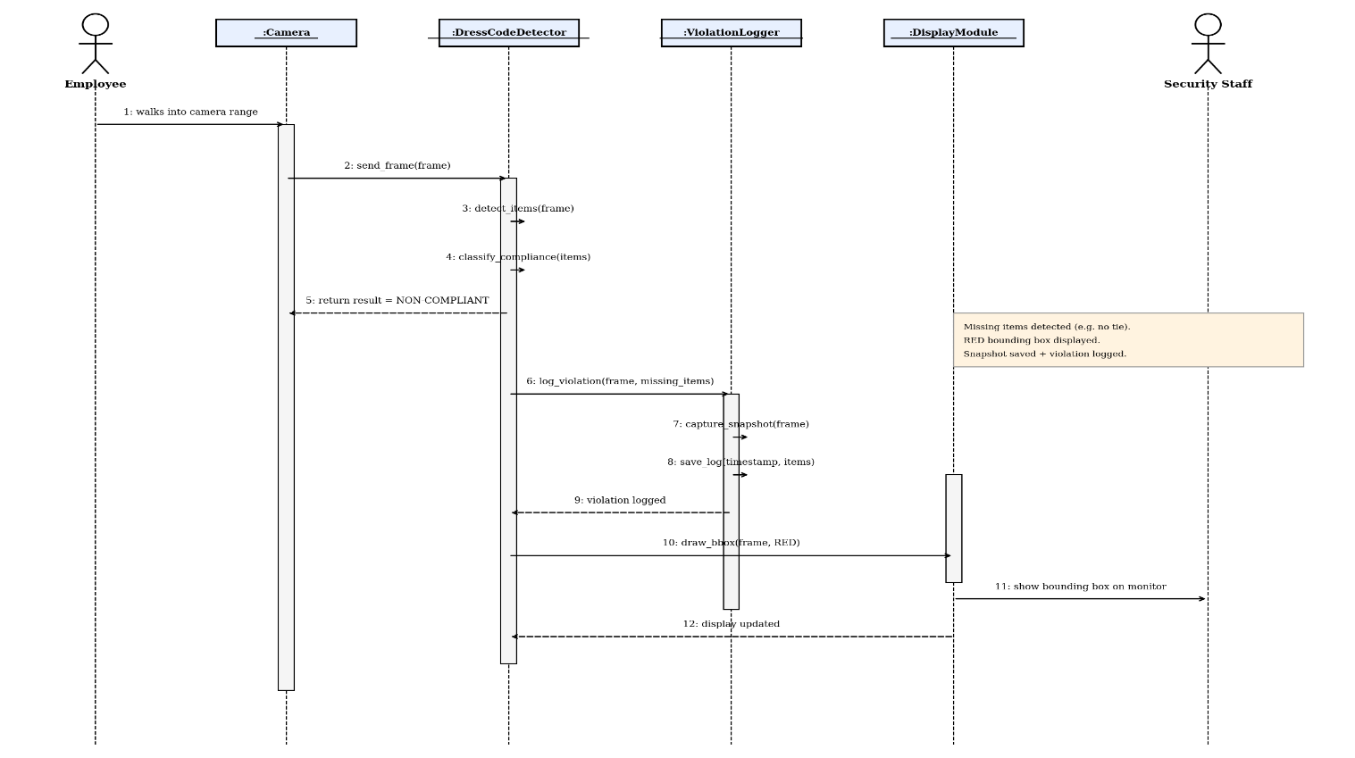

Collaboration diagram:

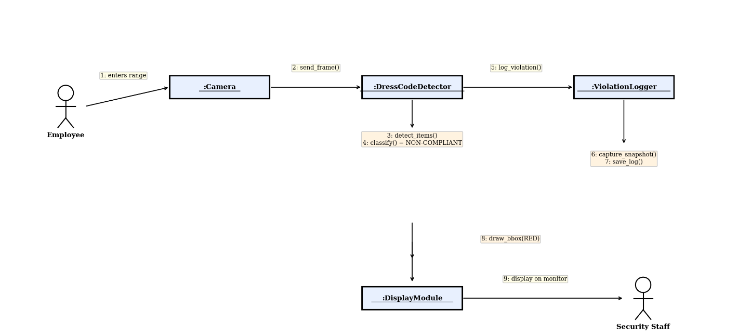

Estimation

Cost Benefit Estimation
Development Costs (One Time):

Item | Cost (PKR)
Developer salary (4 months) | 200,000
Computer with GPU (NVIDIA 4GB) | 150,000
CCTV Camera (720p HD) | 15,000
Software Licenses(Python, Libraries) | 0
Dataset collection and Labelling | 20,000
Testing and Deployment | 15,000
Total Development Cost | 400,000

Annual Operating Costs:

Item | Cost (PKR)
Electricity (system running 8hrs/day) | 25,000
Maintenance and Bug Fixes | 30,000
Storage for Snapshots (external HDD) | 5,000
Total Annual Operating Cost | 60,000

Annual Benefits:

Benefit | Savings (PKR)
Reduction in manual security guard salary (1 guard replaced) | 240,000
Reduced HR time spent on manual monitoring | 60,000
Improved employee discipline (fewer policy violations) | 50,000
Automated report generation (saves admin hours) | 30,000
Total Annual Benefit | 380,000

Return of Investment (ROI) {1st year}
Formula: ROI = (Total Benefits - Total Costs) / Total Costs × 100

Total Cost in 1st Year = Development Cost + Operating Cost = 400,000 + 60,000 = 460,000
Total Benefit in 1st Year = 380,000
ROI = (380,000 - 460,000) / 460,000 × 100 = -17.39%

The cost of development is high and it is a one-time cost so the ROI is negative in the first year. But from the second year onwards, the cost decreases substantially as development cost is no longer involved.

%gain on ROI {1st year}
% Gain = (Annual Benefit / Total Investment) x 100
% Gain = (380,000 / 460,000) × 100 = 82.6%

So, in the first year itself, the system pays back 82.6% of the investment.

Payback Period in years
Formula: Payback Period = Total Investment / Annual Net Benefit

Annual Net Benefit = Annual Benefit - Annual Operating Cost = 380,000 - 60,000 = 320,000
Payback Period = 400,000 / 320,000 = 1.25 years

The system will pay itself out in 1.25 years. Thereafter it saves 320,000 PKR per annum.

FP based Estimation
Step 1: Identify Function Point components

Component | Type | Count | Complexity | FP Weight | Total
Live Video Feed Input | External Input (EI) | 1 | High | 6 | 6
Dress Code Detection | External Input (EI) | 1 | High | 6 | 6
Violation Snapshot Capture | External Input (EI) | 1 | Average | 4 | 4
System Configuration | External Input (EI) | 1 | Low | 3 | 3
Bounding Box Display | External Output (EO) | 1 | High | 7 | 7
Daily Compliance Report | External Output (EO) | 1 | High | 7 | 7
Violation History View | External Output (EO) | 1 | Average | 5 | 5
System Status Display | External Output (EO) | 1 | Low | 4 | 4
Violation Record Query | External Inquiry (EQ) | 1 | Average | 4 | 4
Report by Date Query | External Inquiry (EQ) | 1 | Low | 3 | 3
Detection Records | Internal Logical File (ILF) | 1 | Average | 10 | 10
Daily Reports | Internal Logical File (ILF) | 1 | Low | 7 | 7
User Records | Internal Logical File (ILF) | 1 | Low | 7 | 7
CCTV Camera Feed | External Interface File (EIF) | 1 | High | 10 | 10
Total Unadjusted Function Points (UFP) |  |  |  |  | 83

Step 2: Value Adjustment Factor (VAF)

General System Characteristic | Rating (0-5)
Data Communications | 2
Distributed Data Processing | 0
Performance | 4
Heavily Used Configuration | 3
Transaction Rate | 4
Online Data Entry | 3
End User Efficiency | 3
Online Update | 2
Complex Processing | 4
Reusability | 3
Installation Ease | 2
Operational Ease | 3
Multiple Sites | 1
Facilitate Change | 2
Total Degree of Influence (TDI) | 36

VAF = 0.65 + (0.01 × TDI) = 0.65 + 0.36 = 1.01
Step 3: Adjusted Function Points
AFP = UFP × VAF = 83 × 1.01 = 83.83 ≈ 84 FP
Step 4: Effort Estimation
At 10 hour per function point industry average:
Effort = 84 × 10 = 840 person-hours
Working 8 hours per day = 840 / 8 = 105 working days ≈ 3.5 months

COCOMO Estimation
Step 1: Estimate Lines of Code (KLOC)

Module | Estimated Lines of Code
Camera Module | 200
Detection Module (YOLOv8 integration) | 500
Compliance Logic | 300
Violation Logger | 400
Report Generator | 350
Display Module | 250
User Authentication | 200
System Configuration | 150
Total | 2,350 LOC = 2.35 KLOC

Step 2: COCOMO Model (Basic — Organic Mode)
For organic mode (small team, familiar environment):
Parameter | Value
a | 2.4
b | 1.05
c | 2.5
d | 0.38
Effort (E) = a × (KLOC) a^b E = 2.4 × (2.35)^1.05 E = 2.4 × 2.44 E = 5.86 person-months Development Time (T) = c × (E)^d T = 2.5 × (5.86)^0.38 T = 2.5 × 2.04 T = 5.1 months Average Staff Required = E / T Staff = 5.86 / 5.1 = 1.15 ≈ 1-2 persons
Step 3: Summary
Metric | Value
Total Lines of Code | 2,350 (2.35 KLOC)
Effort Required | 5.86 person-months
Development Time | 5.1 months
Team Size | 1-2 developers
Cost (at 50,000 PKR/month) | 293,000 PKR

References
- Object Detection model refrence:

Ultralytics, "YOLOv8 Documentation," 2023.
https://docs.ultralytics.com/

- Lecture Slides From instructor for cocomo estimation, uml, dfd and other topics.

- Tools and software:
Python 3.8, opencv, PyTorch, Pandas Roboflow.

- Project Concept:
https://arxiv.org/abs/2404.00645

- Dataset:
Checked some datasets with the concept of project on kaggle and roboflow.

Appendix A: Glossary
Term Description
AI Artificial Intelligence - the ability of a computer to perform tasks that normally require human intelligence.
YOLO You Only Look Once - object detection model for real-time image recognition.
YOLOv8 The latest version of the YOLO model by Ultralytics.
OpenCV Open Source Computer Vision Library - used for video and image processing in Python.
PyTorch An open-source machine learning framework used to train AI models
CCTV Closed-Circuit Television - camera system for surveillance
GPU Graphics Processing Unit - hardware required for high-speed processing of AI models
VRAM Video RAM - memory used by the GPU during processing
Bounding Box A rectangle around object detected in an image or video frame
Compliance Being in accordance with the defined dress code rules of the company

